Based on article from <https://randomnerdtutorials.com/esp32-firebase-realtime-database/>. (Thanks Sara & Rui)

First of all, we need to setup a project on the Google Firebase.

**[1] Name the new Project and hit on Continue**

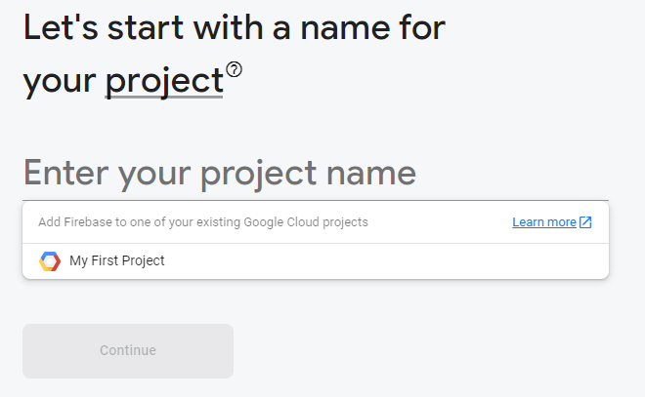

**[2] Disable Google Analytics**



[3] Go to Menu/Authentication and add a user

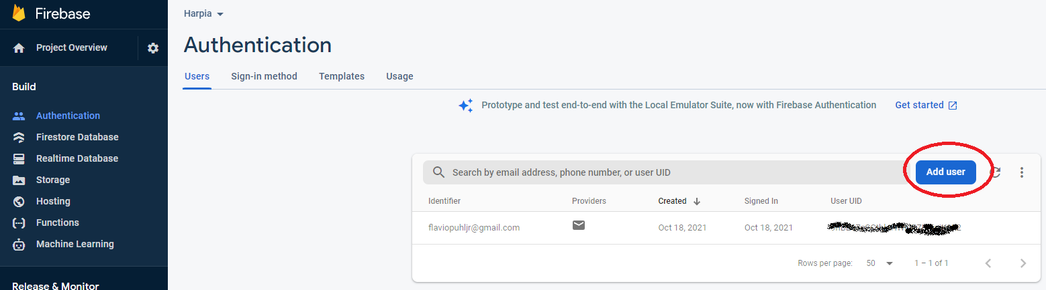

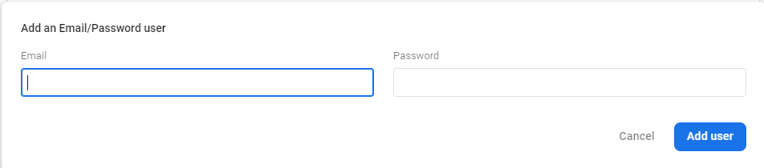

[4] Go to Menu/Storage and create a storage with default options (just click on next and done). Copy the BucketId to use later.

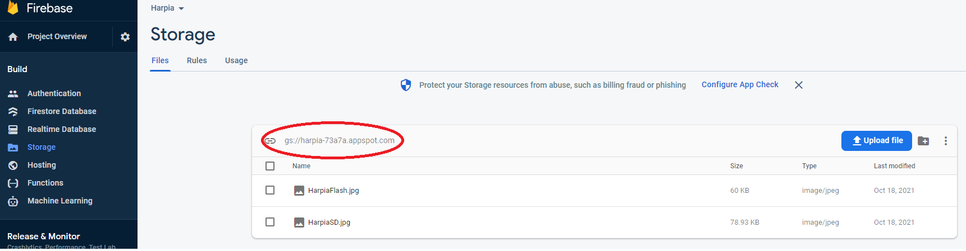

[5] Go to Project Setting and copy the AppKey to use later

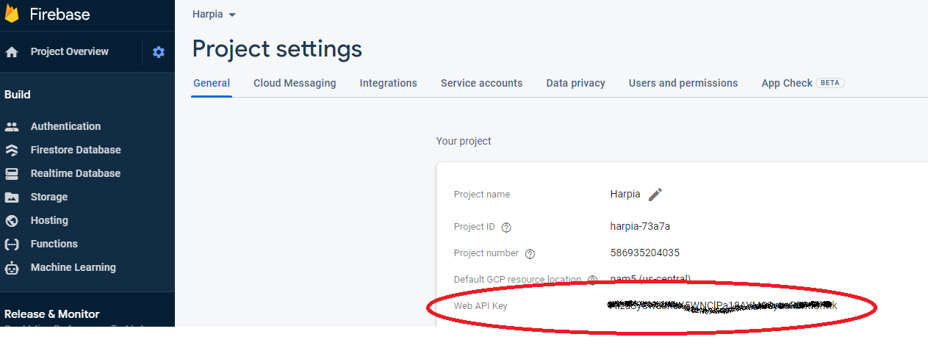

Upload sketch to ESP32 CAM

[1] If you’re using Arduino IDE, follow the next steps to install the library.

1. Go to Sketch > Include Library > Manage Libraries
2. Search for Firebase ESP Client and install the Firebase Arduino Client Library for ESP8266 and ESP32 by Mobitz.

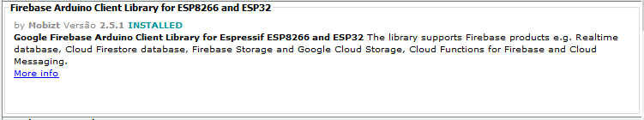

[2] IMPORTANT: To be able to use the native SD card from ES32 CAM the following code must be changed on the library file “FirebaseFS.h”

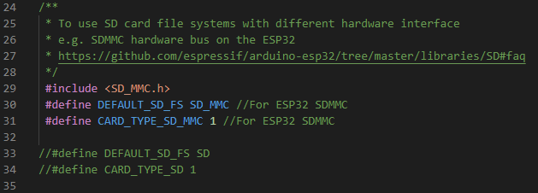

[3] Download the attached example “FirebaseUploadFilefromSD_Test_Dummy.ino”

[4] Update the following code portion with the content saved on previous steps

//Provide the token generation process info.

#include "addons/TokenHelper.h"

/* 1. Define the WiFi credentials */

#define WIFI_SSID "WIFI_SSID"

#define WIFI_PASSWORD "WIFI_PASSWORD"

/* 2. Define the API Key */

#define API_KEY "API_KEY"

/* 3. Define the user Email and password that alreadey registerd or added in your project */

#define USER_EMAIL "USER_EMAIL"

#define USER_PASSWORD "USER_PASSWORD"

/* 4. Define the Firebase storage bucket ID e.g bucket-name.appspot.com */

#define STORAGE_BUCKET_ID "STORAGE_BUCKET_ID.appspot.com"

[5] Update the code below to reflect the file name stored on the SD Card

if (Firebase.Storage.upload(&fbdo,

STORAGE_BUCKET_ID /* Firebase Storage bucket id */,

"/HarpiaSD.jpg" /* path to local file */,

mem_storage_type_sd /* memory storage type, mem_storage_type_flash and mem_storage_type_sd */,

"HarpiaSD.jpg" /* path of remote file stored in the bucket */,

"image/jpeg" /* mime type */))

[6] Run it and you shall be able to see you file added to Firebase Storage

